Screenshots

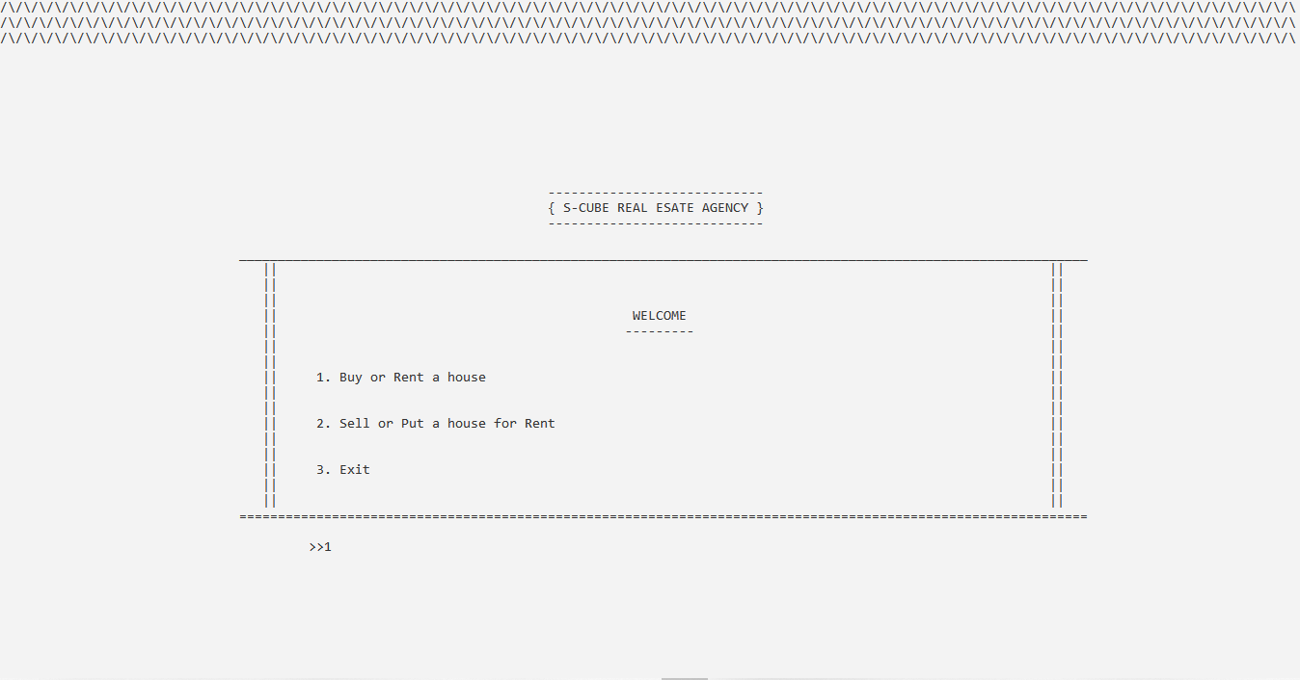

------------------------------------------ Main Menu ------------------------------------------

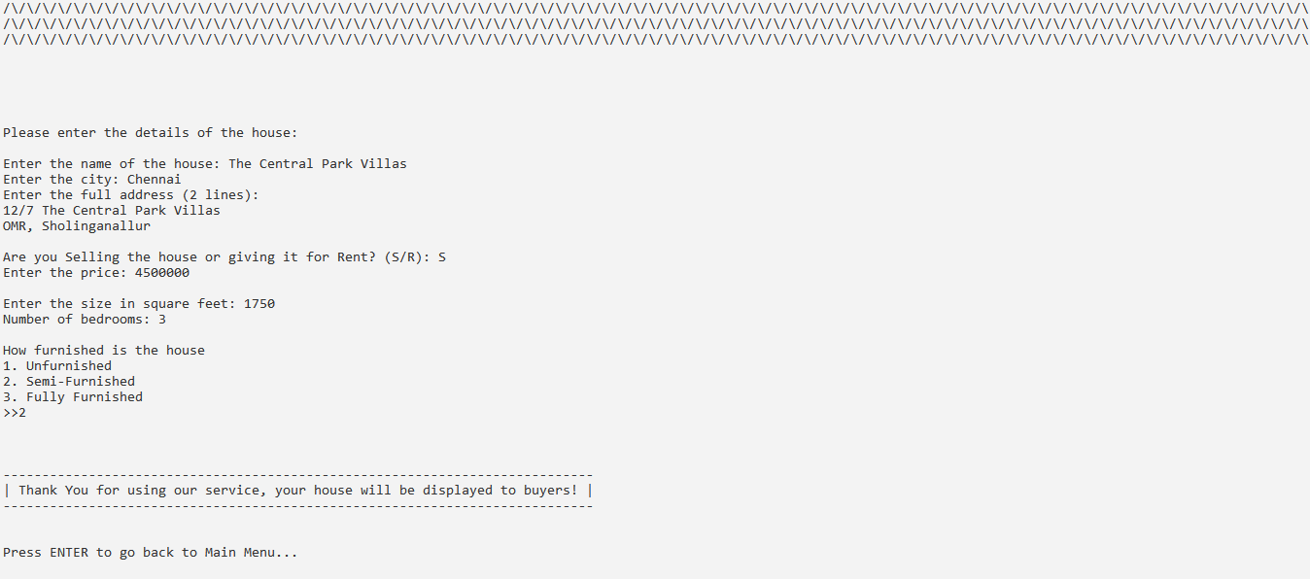

------------------------------------------ Selling a house ------------------------------------------

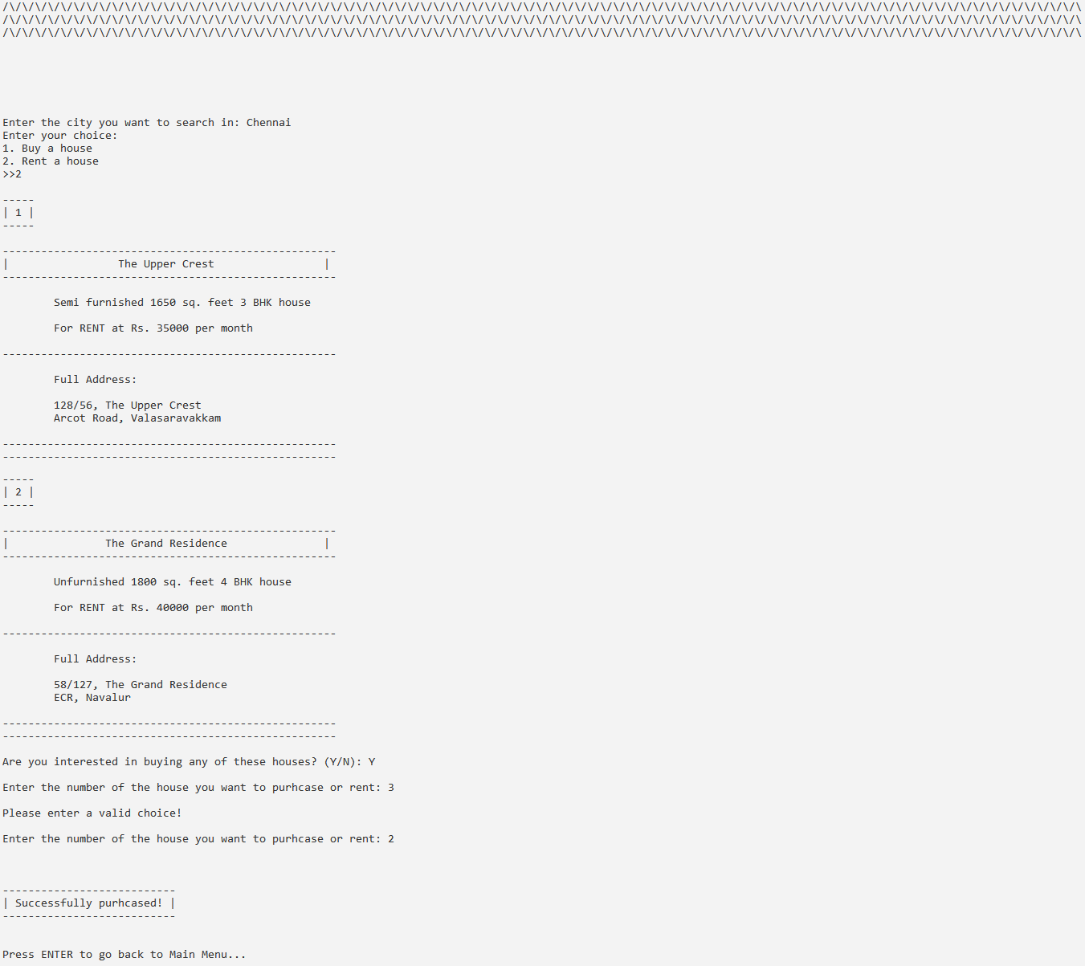

------------------------------------------ Renting a house ------------------------------------------

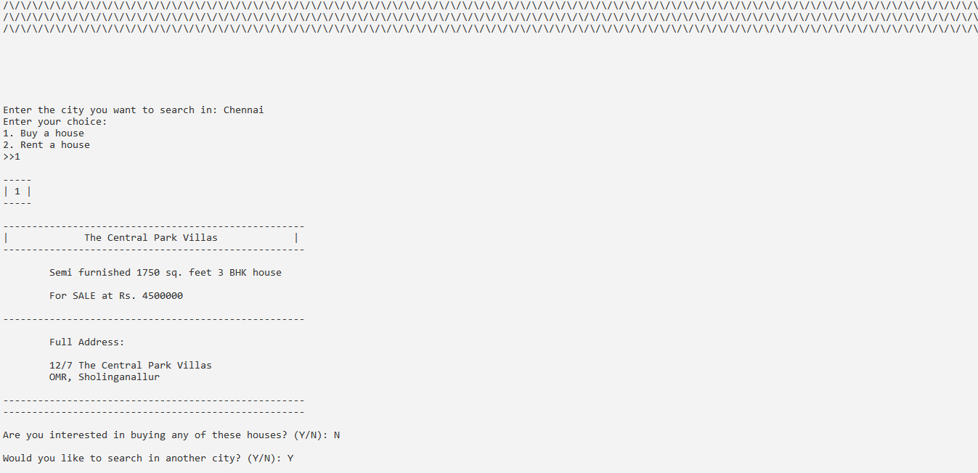

------------------------------------------ Buying a house ------------------------------------------